**NAME: MUHAMMAD HUSSAM (2303.KHI.DEG.020)**

**PAIRING WITH: Mavia Alam Khan (2303.KHI.DEG.017)**

&

**Aqsa Tauheed (2303.KHI.DEG.011)**

**____________________________________________________**

**ASSIGNMENT 2.1**

**Write a bash command which formats markdown**  
**cells in file my_notebook.ipynb (nbqa github page might**  
**be helpful).**  
**nbqa blacken-docs my_notebook.ipynb --nbqa-md**

**SOLUTION:**

We have to format markdown inside cell in jupyter notebook there is code written along with some text inside cell in markdown of jupyter notebook as shown in image below.

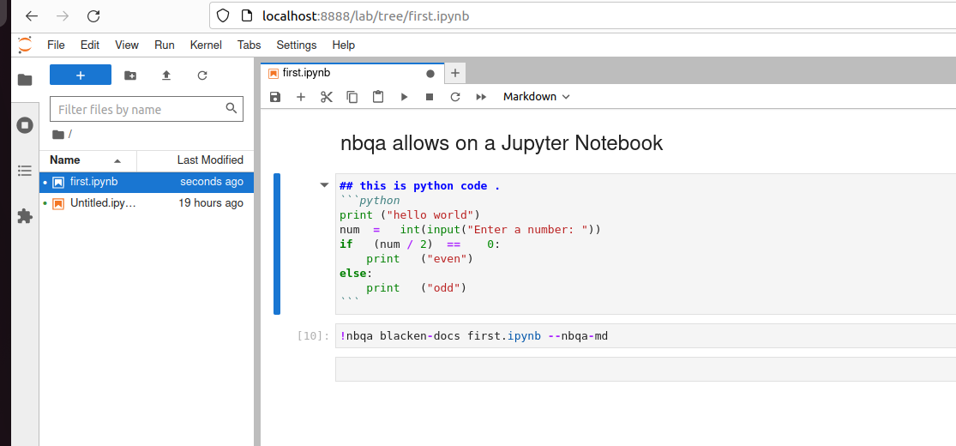

Code written inside the cell is unformatted like there are some extra spacing in code, now we have to format this code. For this we have to install nbqa ,black and blacken in bash/terminal, then we execute the command:

**nbqa blacken-docs first.ipynb --nbqa-md**

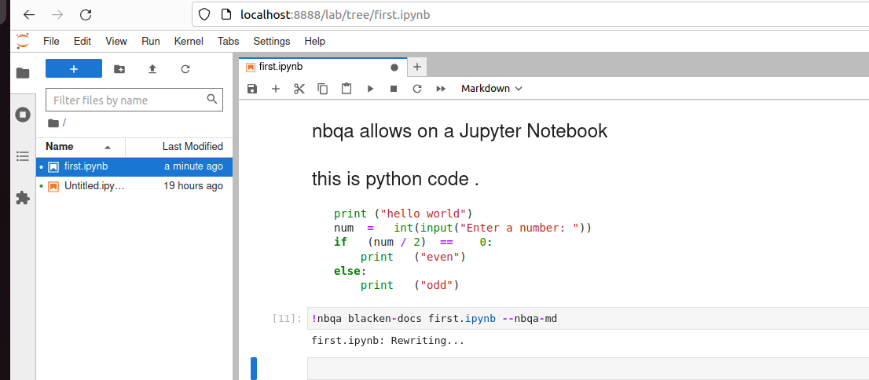

After execution of command , the code will be formatted as shown in image below :

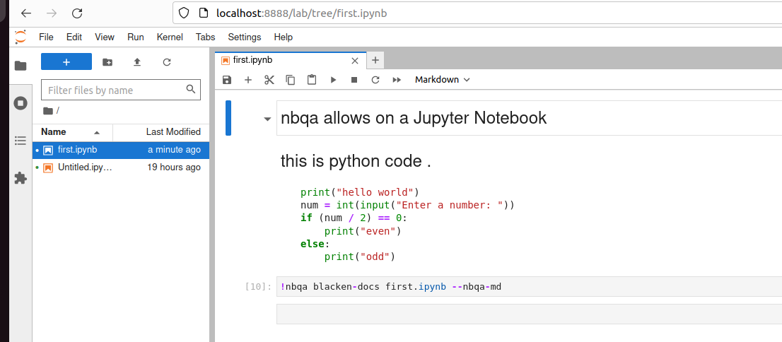

As you can see the image , the spacing inside the python code has been removed and code is formated, Hence the command nbqa blacken-docs my_notebook.ipynb --nbqa-md

works perfectly.